Using AutoCorrect features for Abbreviation Expansion in Microsoft Word

1. Type the words as you want them appear with capitals etc. You can type in multiple lines as well. Then highlight the text you want to abbreviate.

2. A. Click the “Office Button” Icon 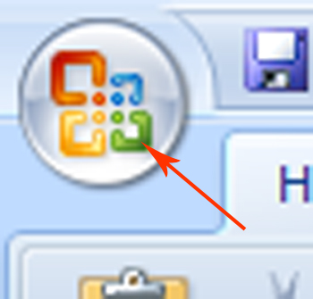 in the upper left corner of MS Word or it may say “File”.
B. Next click “Word Options” or “Options” on the bottom of the window.
C. Then click the “Proofing” tab.
D. The click the “Autocorrect Options” button.

3. The text you highlighted should be in the “with” window.
Type in the abbreviation in the replace window.
Note about selecting an abbreviation:
Make sure the abbreviation is not a word or text that you would type by itself. For example, using the abbreviation “dr” for the Department of Rehabilitation would not be good because every time the user tried to type the abbreviation for “drive” (dr.) or “doctor” (Dr.) the word would automatically be expanded out to the Department of Rehabilitation. Since Department of Rehabilitation uses DOR as an acronym that would not be a good choice. A better abbreviation would be “drb” or “dr1” since this is not used often by itself.

4. Test the abbreviation by typing in the text and then add either a space, period, comma or enter key and the abbreviation should be expanded.

